**Power Consumption Analysis for House Holds**

**INTRODUCTION:**

Electricity load forecasting has gained substantial importance nowadays in the modern electrical power management systems with elements of smart greed technology. A reliable forecast of electrical power consumption represents a starting point in policy development and improvement of energy production and distribution. At the level of individual households, the ability to accurately predict consumption of electricity power significantly reduces prices by appropriate systems for energy storage. Therefore, the energy efficient power networks of the future will require entirely new ways of forecasting demand on the scale of individual households.

The analysis of a time series used forecasting techniques to identify models from the past data. With the assumption that the information will resemble itself in the future, we can thus forecast future events from the occurred data. There are several techniques of forecasting, and these techniques provide forecasting models of different accuracy. The accuracy of the prediction is based on the minimum error of the forecast. The appropriate prediction methods are considered from several factors such as prediction interval, prediction period, characteristic of time series, and size of time series.

In this research, we are interested in time series analysis with the popular forecasting technique that we I applied this method for detecting patterns and trends of the electric power consumption in the household with real time series period in daily, weekly, monthly, and quarterly. we used Python program for constructing the model.

**OVERVIEW:**

Electricity consumption is an essential component of the modern life. It not only provides clean and safe light throughout the day. In all countries, it allows the use of electrical and electronic equipment in which the use of electricity is essential to ensure their proper functioning. In India growth has increased very rapidly since the early 1950s and has been mainly constrained by the ability of the growing state electricity grids to meet rising demands for peak capacity and energy needed for the modernization and growth of the industrial and agricultural sectors. This Guided Project mainly focuses on applying a machine-learning algorithm to calculate the power consumed by all appliances.  This will help you track the power consumed on regular intervals for all kinds of appliances which use heavy loads such as Air Conditioners, Oven or a washing machine etc.

1- Exploratory Data Analysis

2- Data Visualization

3- Analysis from Data Visualization

4- Train and Test Split

5- Data Pre-processing

6- Machine Learning Algorithms Used:

* Linear Regression

7- Results and Comparison.

**LITERATURE SURVEY**:

**Existing Problem:**

Given the rise of smart electricity meters and the wide adoption of electricity generation technology like solar panels, there is a wealth of electricity usage data available. This data represents a multivariate time series of power-related variables, that in turn could be used to model and even forecast future electricity consumption. In this, you will discover a household power consumption dataset for multi-step time series forecasting and how to better understand the raw data using exploratory analysis.

**PROPOSED SOLUTION:**

* The household power consumption dataset that describes electricity usage for a single house over four years.
* How to explore and understand the dataset using a suite of line plots for the series data and histogram for the data distributions.
* How to use the new understanding of the problem to consider different framings of the prediction problem, ways the data may be prepared, and modelling methods that may be used.

**THEORITICAL ANALYSIS:**

**Block Diagram:**

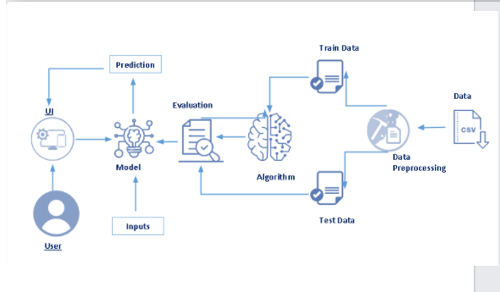

**DATASET DESCRIPTION:**

The Household Power Consumption dataset is a multivariate time series dataset that describes the electricity consumption for a single household over four years.

This archive contains 2075259 measurements gathered in a house located in Sceaux (7km of Paris, France) between December 2006 and November 2010 (47 months).

It is a multivariate series comprised of seven variables (besides the date and time); they are:

• Global_active_power: The total active power consumed by the household (kilowatts).

• Global_reactive_power: The total reactive power consumed by the household (kilowatts).

• Voltage: Average voltage (volts).

• Global_intensity: Average current intensity (amps).

• Sub_metering_1: Active energy for kitchen (watt-hours of active energy).

• Sub_metering_2: Active energy for laundry (watt-hours of active energy).

• Sub_metering_3: Active energy for climate control systems (watt-hours of active energy).

**Software Designing:**

* Numpy and Pandas : Open-source data analysis and manipulation tool, built on top of the Python programming language.
* Matplotlib and Seaborn : Used for visualisation with python.
* The finalised model is now to be saved. We will be saving the model as a pickle or pkl file.
* HTML pages “pca.html” for our home page and “result1.html” which comes to use when we print out the final predictions made, both are stored in the templates folder .
* Let us build app.py flask file which is a web framework written in python for server-side scripting. Let’s see step by step procedure for building the backend application Import required libraries.
* Configure app.py to fetch the user inputs from the UI, process the values, and return the prediction.

**EXPERIMENTAL INVESTIGATION:**

This research used electric consumption in one household dataset obtained from UCI Machine Learning Repository for evaluating the time series models. This dataset has 9 attributes and 2,075,259 transactions. The time series data was divided into two groups. The first group was training dataset which contain data from 2006-12-26 to 2009-12-31 for construction the forecasting models. The second group was test dataset which contain data from 2010-01-01 to 2010-11-26 for finding the most suitable forecasting period.

**FLOW CHART:**

**RESULT:**

The purpose of this research was to find a suitable model to forecast the electric consumption in a household, and to find the most suitable forecasting period (in daily, weekly, monthly, or quarterly). We used the individual household electric power consumption from December 2006 to November 2010. Then, chose the suitable forecasting method and identified the most suitable forecasting period.

**Output:**

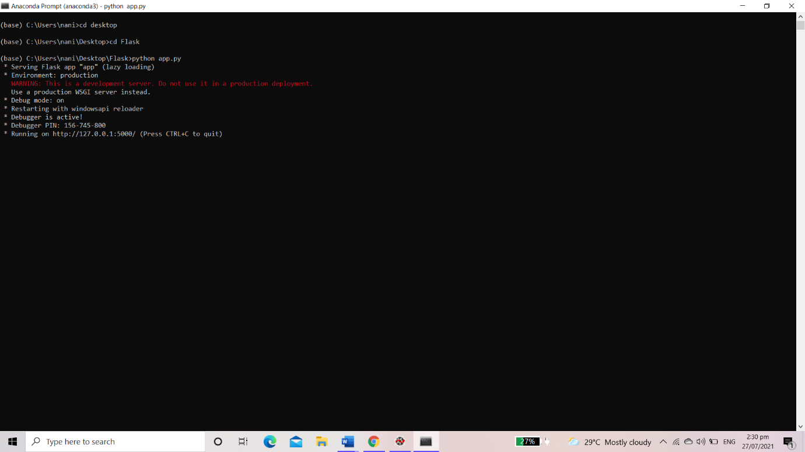

Let’s see how our output page looks like:

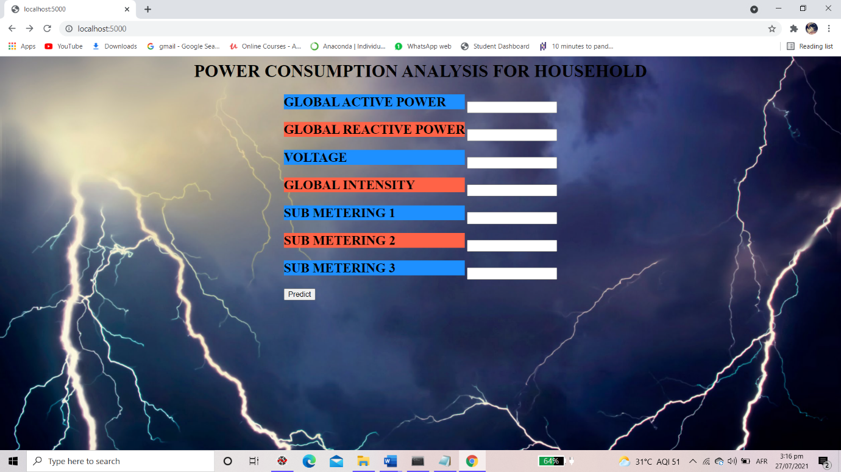

Enter the values

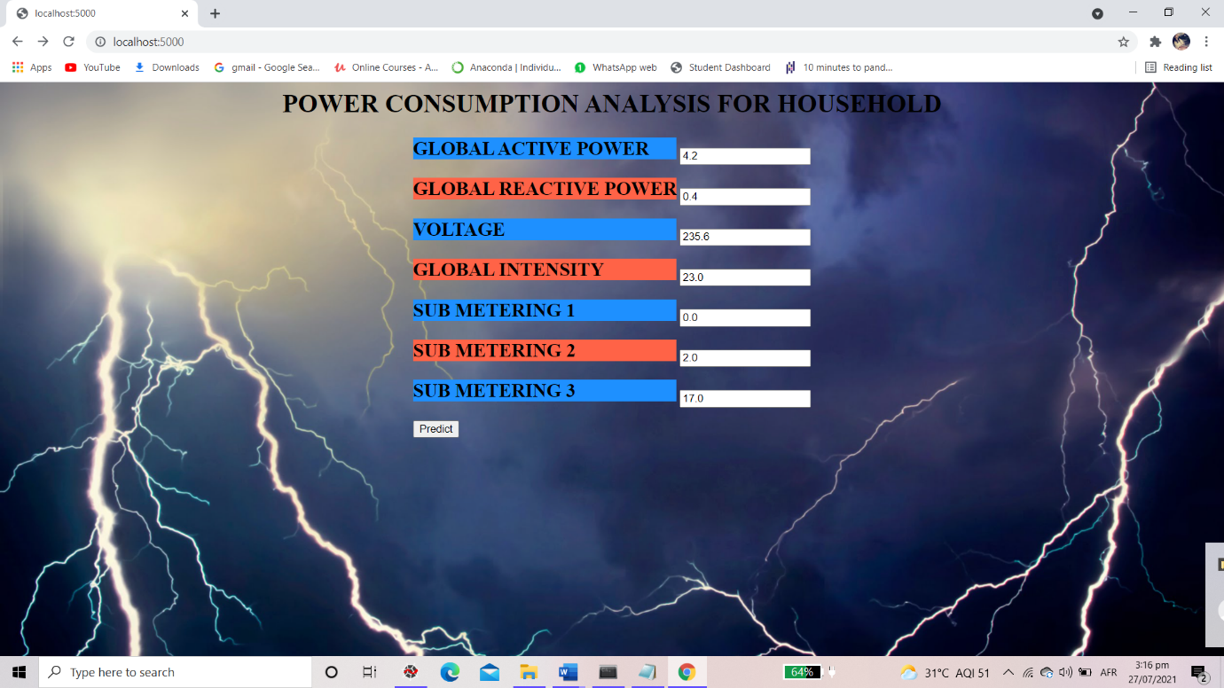

When you click predict, the output is rendered to new page,

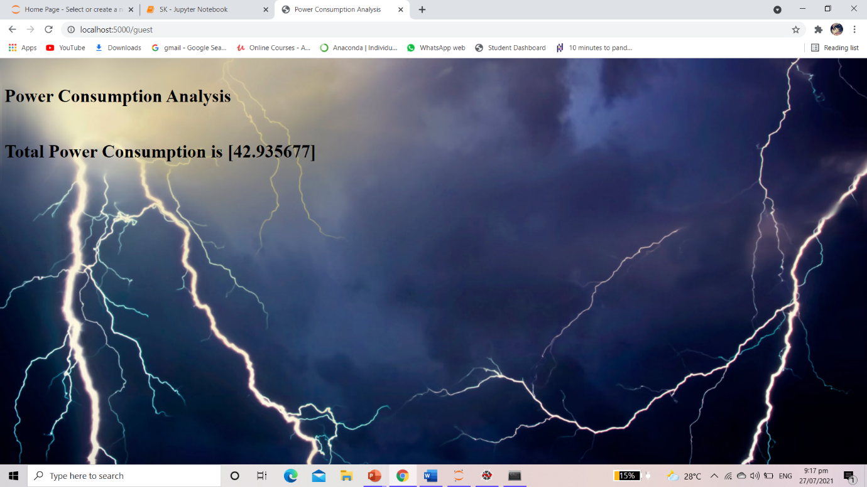

**APPLICATIONS:**

With such data, the power consumption of individual households can be tracked in almost real-time. Such prediction can help power companies regulate their supply; also, the consumer can use this information to make better decisions both financially and environment-consciously

**CONCLUSION:**

The research project is done keeping the aim to reduce household power consumption while fulfilling the needed demands of electricity of users. The project can also be modified to be used to optimize industrial power consumption and other places to reduce load on grids. Connecting it with a chat bot or make a web application based on the same concept can increase the efficiency of the project to a great extent. With the application load consumption can be reduced as achieved from the results and pressure on mineral resources for electricity production can also be reduced. For a greener planet, the application can raise a massive awareness. The general people, especially from the developing countries are hoped to be benefited by this research work.

**BIBLIOGRAPHY:**

L. Breiman, 2001. [Random forests](https://www.stat.berkeley.edu/users/breiman/randomforest2001.pdf), Machine Learning 45.1: 5–32

Tae-Young Kim and Sung-Bae Cho, 2019. [Predicting residential energy consumption using CNN-LSTM neural networks](https://www.sciencedirect.com/science/article/abs/pii/S0360544219311223?via%3Dihub). Energy, Volume 182: 72–81. <https://doi.org/10.1016/j.energy.2019.05.230>

X. M. Zhang, K. Grolinger, M. A. M. Capretz and L. Seewald, 2018. [Forecasting Residential Energy Consumption: Single Household Perspective](https://ieeexplore.ieee.org/document/8614049). 17th IEEE International Conference on Machine Learning and Applications (ICMLA), Orlando, FL, 2018: 110–117, doi: [10.1109/ICMLA.2018.00024](https://doi.org/10.1109/ICMLA.2018.00024)

**APPENDIX:**

Python (source code):

from flask import Flask, render_template, request

app = Flask(__name__)

import pickle

import numpy as np

model = pickle.load(open("lr.pkl","rb"))

@app.route('/')

def hello_world():

return render_template("index.html")

@app.route('/guest' , methods = ["POST"])

def Guest():

gap = request.form["gap"]

grp = request.form["grp"]

v = request.form["v"]

gi = request.form["gi"]

s1 = request.form["s1"]

s2 = request.form["s2"]

s3 = request.form["s3"]

arr= np.array([gap,grp,v,gi,s1,s2,s3])

user_input_prediction = arr.astype('float32')

prediction = model.predict([user_input_prediction])

return render_template("output.html", y="Total Power Consumption is " +str(prediction))

if __name__ == '__main__':

app.run(debug = True)